RAIN


Web Based Internship Vacancy Application
R E A D Y F O R I N T E R N S H I P







 P B L - T R P L 1 0 9 2 0 2 5

Meet Our Team




Leader
Eric Marchelino Hutabarat 4342401060
UI/ UX Designer & Tester

Wasyn Sulaiman Siregar 43424010
Frontend Developer

Indria Bintani Aiska 43424010
Backend Developer





Muhammad Aidil J. Saleh 43424010
Analyst

Fito Desta Fabiansah 43424010
Analyst

Winda Tri Wulan Dari 43424010
Analyst



What is “Ready for Internship”?
The Web Based Internship Vacancy Application or “Ready for Internship” is a digital platform specifically designed to facilitate the internship recruitment process. This web based application was created with the aim of providing services to Polibatam students and companies in carrying out the internship recruitment process.

Software Features
Some of Our Application Features are :

Search by Vacancy Title Filter with 3 Categories Vacancy Posting
Vacancy Management
Applicant Management Account Management
Profile Management
Application and Interview Status








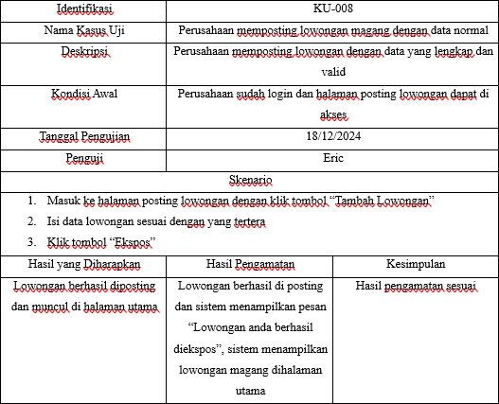
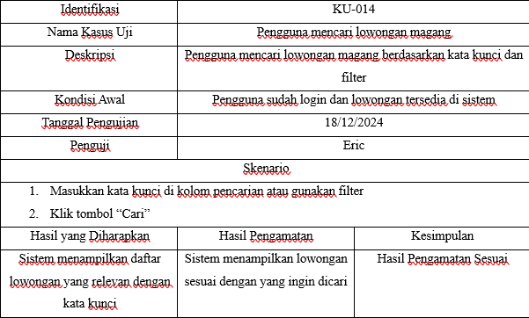
RAIN
Software Testing Results


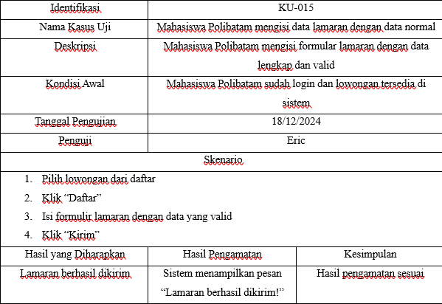
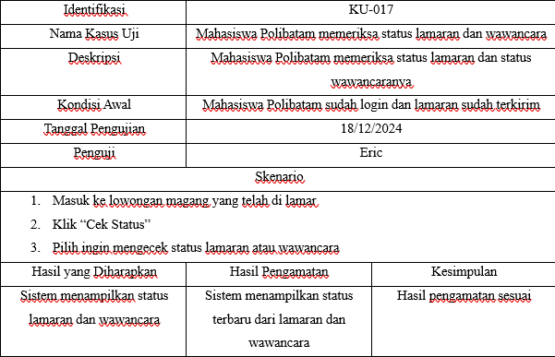

Software Relationships With Subjects
RPL101
This Web application was created by performing the stages of software development, as well as documenting and presenting it
Introduction to Software Engineering
RPL104
The requirements present in this Web Application are validated in the form of SRS or
documents
Software Requirements
Analysis and Specification
RPL105
Coding in this web application based on requirements using web-based programming
languages
Web Based Programming
RPL106
The database in this Application is based on requirements supported by
ERD
Introduction to Databases



So, what is the conclusion of this product?
This Web based Internship Vacancy Application called “Ready for Internship” was created by the PBL-TRPL109 team. Overall, the implementation of the RAIN web application will help simplify the internship recruitment process, providing significant benefits in efficiency and coordination in the internship recruitment process.

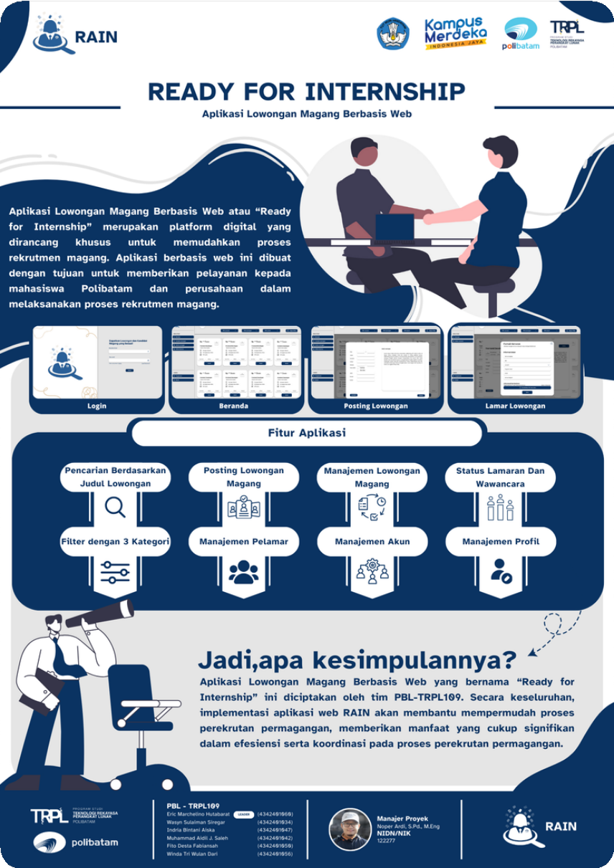
P O S T E R

